
LOYOLA COLLEGE (AUTONOMOUS), CHENNAI – 600 034
B.Sc. DEGREE EXAMINATION – STATISTICS
SECOND SEMESTER – APRIL 2011

ST 2502/ST 2501 - STATISTICAL MATHEMATICS - I

Date : 08-04-2011 Dept. No. Max. : 100 Marks
Time : 9:00 - 12:00

PART – A

Answer ALL questions (10x2 =20 Marks)

- Define least upper bound of a set.
- Define convergent sequence.
- Define cumulative distribution function and state any two of its properties.
- Give an example for a monotonic sequence.
- Define absolute convergence and conditional convergence for a series of real numbers.
- Define M.G. F of a random variable.
- State Roll’s theorem.
- Define Taylor’s expansion of a function about x = a.
- Define rank of a matrix.
- Define symmetric matrix. Give an example.

PART – B

Answer any FIVE questions (5x8=40 Marks)

- Show that every convergent sequence is bounded. Is the converse true? Justify your answer.
- Obtain the c.d.f. of the total number of heads occurring in three tosses of a fair coin.
- Establish the convergence of (a) 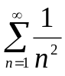 ; (b) 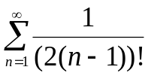.
- Show that if a function is derivable at a point, then it is continuous at that point.
- If two random variables X and Y have the joint probability density
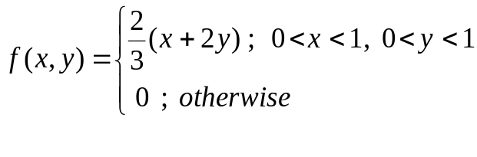
Find the marginal densities.

- Find the Lagrange’s and Cauchy’s remainder after n^{th} term in the Taylor’s series expansion of log_{e}(1+ x).

- Verify whether or not the following sets of vectors form linearly independent sets:
(a) (1, 2, 3), (2, 2, 0)

(b) (3, 1, -4), (2, 2, -3)
- Find the inverse of a matrix 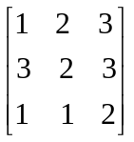 .

PART – C

Answer any TWO questions (2x20=40 Marks)

- (a) Prove that a non-increasing sequence of real numbers which is bounded below is convergent.

(b)Prove that the sequence 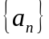 given by 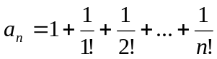 is convergent.

- (a) State and Prove Rolle’s Theorem

(b) Find a suitable c of Rolle’s Theorem for the function

.

- A random variable X has the following probability function

x | 1 | 2 | 3 | 4 | 5 | 6 | 7
P(x) | 0 | k | 2k | 2k | k² | 2k² | 7k²+k

- Find k
- Evaluate (a) 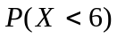 (b) 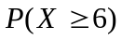 (c) 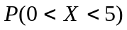
- If 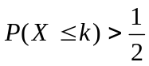, find the minimum value of k
- Determine the distribution function of X.

- (a) If 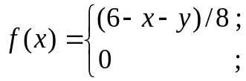 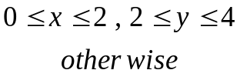
is the joint p.d.f. of X and Y, find the marginal p.d.f.’s. Also, evaluate
P[ (X < 1)  (Y < 3) ]
(b) Find the rank of the matrix 



